November Weeks 2 and 3

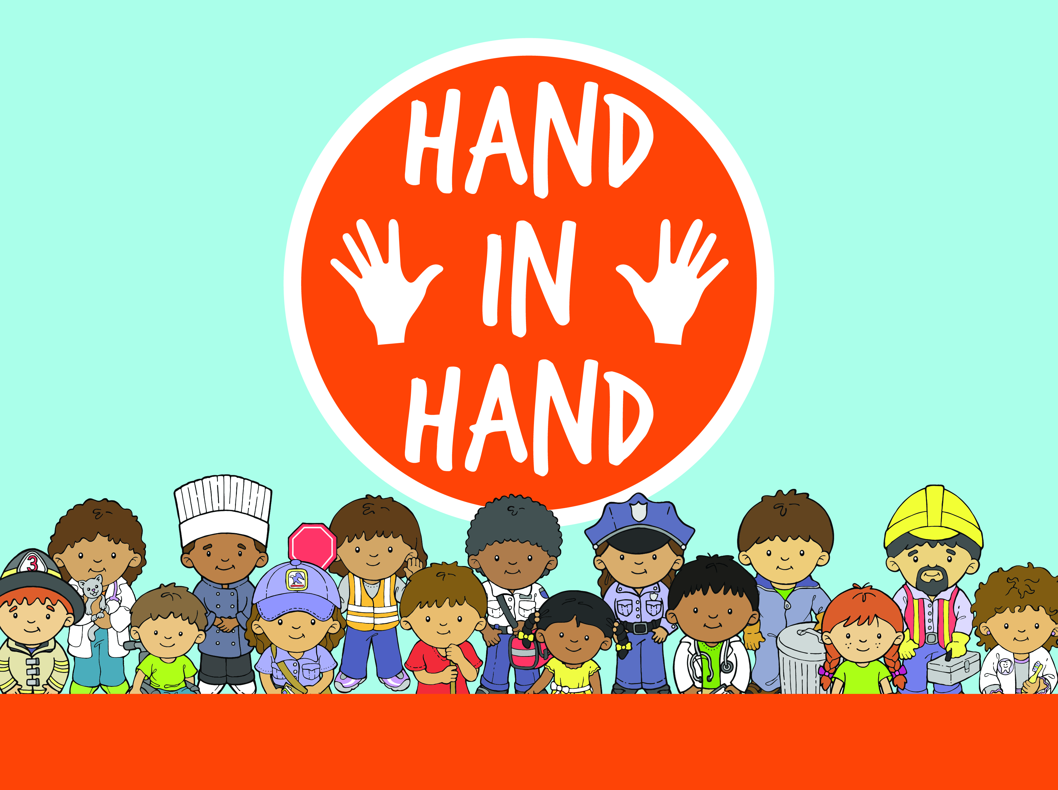
November 11th/12th
November 18th/19th

LG OVERVIEW

NEHEMIAH BUILDS A WALL

WORSHIP LEADER: “Good morning, everyone! It’s so good to see you today. I can’t wait to sing with you today. I can’t wait to talk more about being thankful today. But what do you think we’re going to do first? (Pause) You’re right! We’re going to sing our song. I can’t wait! Before we do, remind me: Who are you thankful for?”

CHILDREN and WORSHIP LEADER: “I am thankful for people who help me!”

WORSHIP LEADER: “Yes, that’s right!!

Lead children in singing “Whoooo I Can Help You” and “Praise the Lord Everyday.”

WORSHIP LEADER: “Yay! What incredible singers you are. Who are you thankful for?”

CHILDREN and WORSHIP LEADER: “I am thankful for people who help me!”

BIBLE VERSE: “That’s right! I am thankful for people who help me! Remember, our memory verse this month tells us who we can thank for these awesome people. Are you ready? (Pause.) Let’s do it! Always give thanks to God, Ephesians 5:20. Let’s try that together.” (Repeat several times.)

STORYTELLER: “I’m so glad to see you today. I have an incredible true story from my very favorite book, the Bible. (Hold up Bible.) And we know that if we read it in the Bible, it’s true! Today’s story is about a man named Nehemiah, and Nehemiah, well, he needed a LOT of help. You see, his hometown, the city of Jerusalem, used to have a big wall around it. The wall protected the people, but Nehemiah found out that the wall was all broken down. Nehemiah wanted to build it back, but he couldn’t do it on his own. He needed help. Do you think anyone will help him? Let watch our story and find out, when I count to three, yell, ‘Tell me a story!’ Ready? One, two, three! (Pause) Awesome! I better go grab a seat so I don’t miss a minute of the Bible lesson.”

Watch video lesson.

STORYTELLER: “What a cool story about people helping each other! I am so thankful Nehemiah got help from his neighbors and I am so thankful for people who help me. Who are you thankful for?”

CHILDREN and STORYTELLER: “I am thankful for people who help me.”

WORSHIP LEADER: “That is awesome. Now it’s time to sing another song!”

Lead children in singing “Together.”

“Wasn’t that a fun song? We are so much better together and when we’re helping one another. Who are you thankful for?”

CHILDREN and WORSHIP LEADER: “I am thankful for people who help me!”

WORSHIP LEADER: “That’s the truth friends - And don’t you forget it! See you next week!”

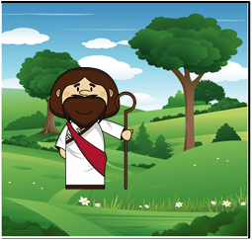

Memory Verse –

“’Come, and follow me,’ Jesus said.”

Matthew 4:19, NIV

